UNIT 2
Lesson 7 – Around the world


PASCAL
EWAN
HARRY

- 1 Do you remember Harry, Ewan and Pascal?
Sjećaš li se dječaka: Harryija, Pascala i Ewana?
They all live in school. Sva tri žive u školi.
Read the text. Find out who doesn't like living at school.
Pročitaj tekst. Saznaj tko ne voli živjeti u školi.
Write the name on the empty line.
Napiši ime na praznu crtu.

_____________________________
Name (ime)

1 Harry lives in a boarding school.
Harry živi u internatu.
He doesn't live with his parents.
On ne živi sa svojim roditeljima.
He lives with his friends and teachers.
On živi sa svojim prijateljima i učiteljima.
He shares his room with his friends.
On dijeli sobu sa svojim prijateljima.
Living with his friends is fun but it can be tricky because he has to learn, too.
Život s prijateljima je zabavan, ali to može biti i nezgodno
jer treba i učiti.
Harry likes living at school.
Harry voli živjeti u školi.

2 Ewan lives at school with his family.
Ewan živi u školi sa svojim prijateljima.
He shares his room with his sister.
On dijeli sobu sa svojom sestrom.
He likes being closed to the school yard because he can play basketball with his friends.
On voli biti blizu školskog igralilišta jer može igrati košarku sa svojim prijateljima.
Ewan likes living at school.
Ewan voli živjeti u školi.

3 Pascal is a school hamster.
Pascal je školski hrčak.
He lives alone in his house.
On živi sam u svojoj kući.
He doesn't have friends.
On nema prijatelja.
He doesn't like living at school.
On ne voli živjeti u školi.
He doesn't like the noise.
On ne voli buku.

- 2 Read the sentences. Pročitaj rečenice.
Tick  the sentences that are true.
Kvačicom označi rečenice koje su točne.
Find the answers in task 1.
Pronađi odgovore u 1. zadatku.

1 Harry and Ewan like living at school.
Harry voli živjeti u školi.

2 Pascal doesn't like living at school.
Pascal ne voli živjeti u školi.
3 Harry and Ewan don't have friends.

Harry i Ewan nemaju prijatelje.

4 Pascal shares his room.
Pascal dijeli svoju sobu s nekim.

5 Pascal lives with his family.
Pascal živi sa svojom obitelji.

6 Ewan likes being close to a yard.
Ewan voli biti blizu školskog dvorišta.

- 3 Harry, Ewan and Pascal's room are all different.
Harry, Ewan i Pascal imaju različito uređene sobe.
Some things in their rooms are simliar.
Neke stvari u njihovim sobama su slične.
Some things are different.
Neke stvari u njihovim sobama su različite.
Take a look at the two rooms.
Pogledaj dvije sobe na slikama.
Notice what is similar and what is different.
Pokušaj zamijetiti što je slično,a što je različito.

A 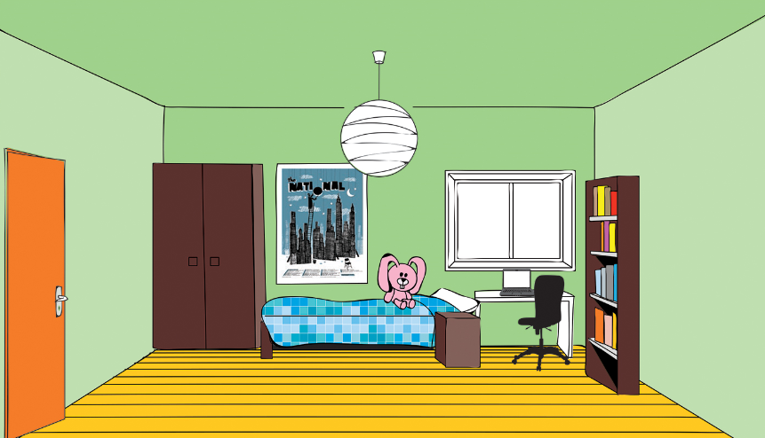
B 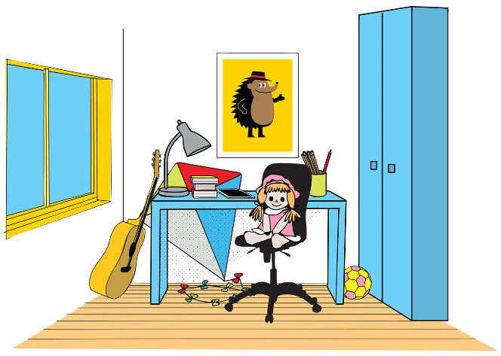

 | Similar  Slično | Different  Različito
The number of the windows.
Broj prozora.
The colour of the windows.
Boja prozora.
The number of the doors.
Broj vrata.
The colour of the doors.
Boja vrata.
The number of the desks.
Broj stolova.
The colour of the desks.
Boja stolova.
The number the chairs.
Broj stolica.
The colour of the chairs.
Boja stolica.

- 4 Look at the photos of three different rooms.
Pogledaj slike tri različite sobe.
Talk to your classmate about the differences and similarities.
Razgovaraj sa svojim prijateljem iz klupe o razlikama i sličnostima.

1 What is different? 2 What is similar?
Što im je slično? Što im je različito?
3 Which one do you like the best?
Koja ti se soba najviše sviđa?
A 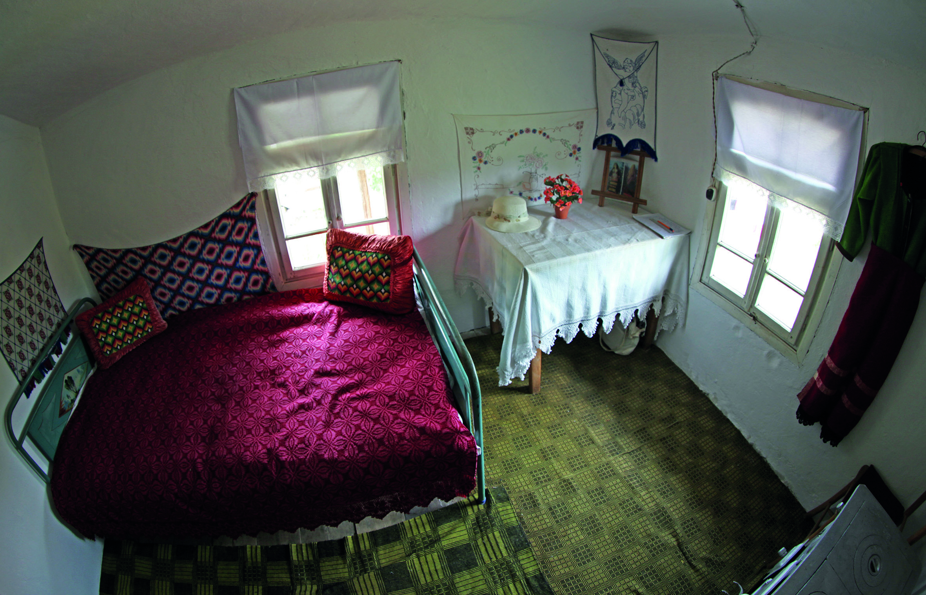

B 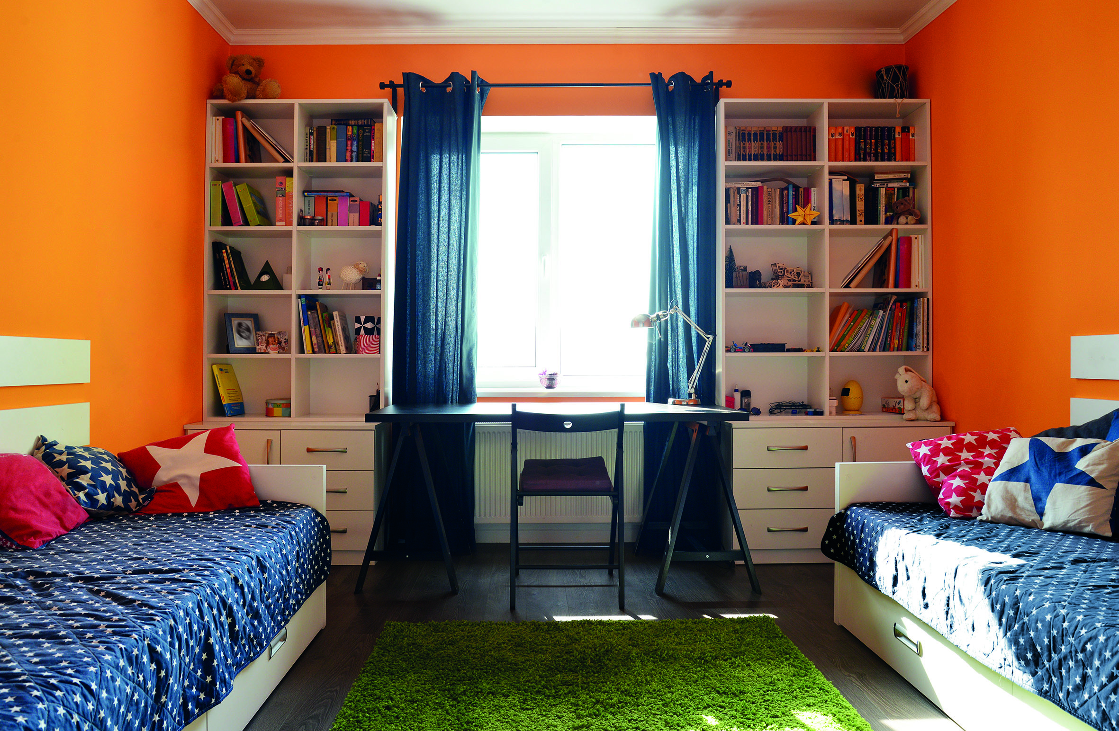

C 